**Report**

**Members: Ciaran O Nuallain, Daniel Tilley, Desmond Dagg, Mark Twomey**

We followed step 2 and 3 exactly. Ciaran originally created the document. Des and Dan added some comments and made changes to the properties. Mark changed some of the properties and then used doc scrubber to analyse the document.

First log:

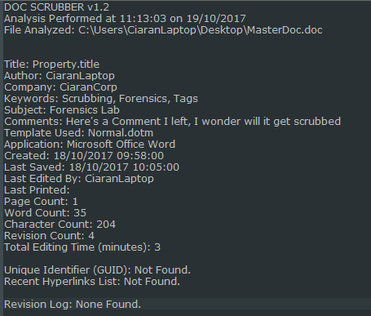

Final log:

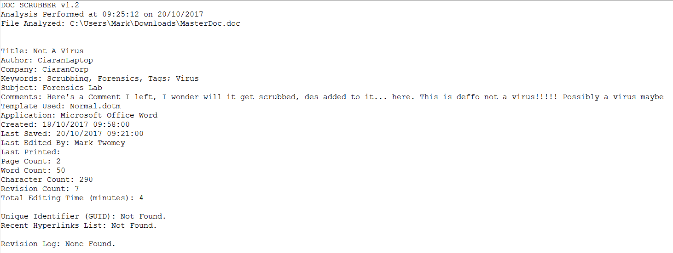

Following this we can conclude that any changes made by any amount of people from the start to the end person won’t be easily visible as seen by the way that the changes Des and Dan made aren’t as evident.

*AutoSave*:

The options for autosave can be accessed by clicking ***File>options>save***

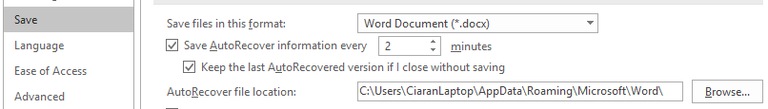

Here we can see the timer for the autosave feature set to 2 minutes even though by default it goes to 10.

We also see the default file path it saves to.

We see in the screenshot below it created a subfolder for the master document and had the autosave file denoted by the .ASD file extension in there.

